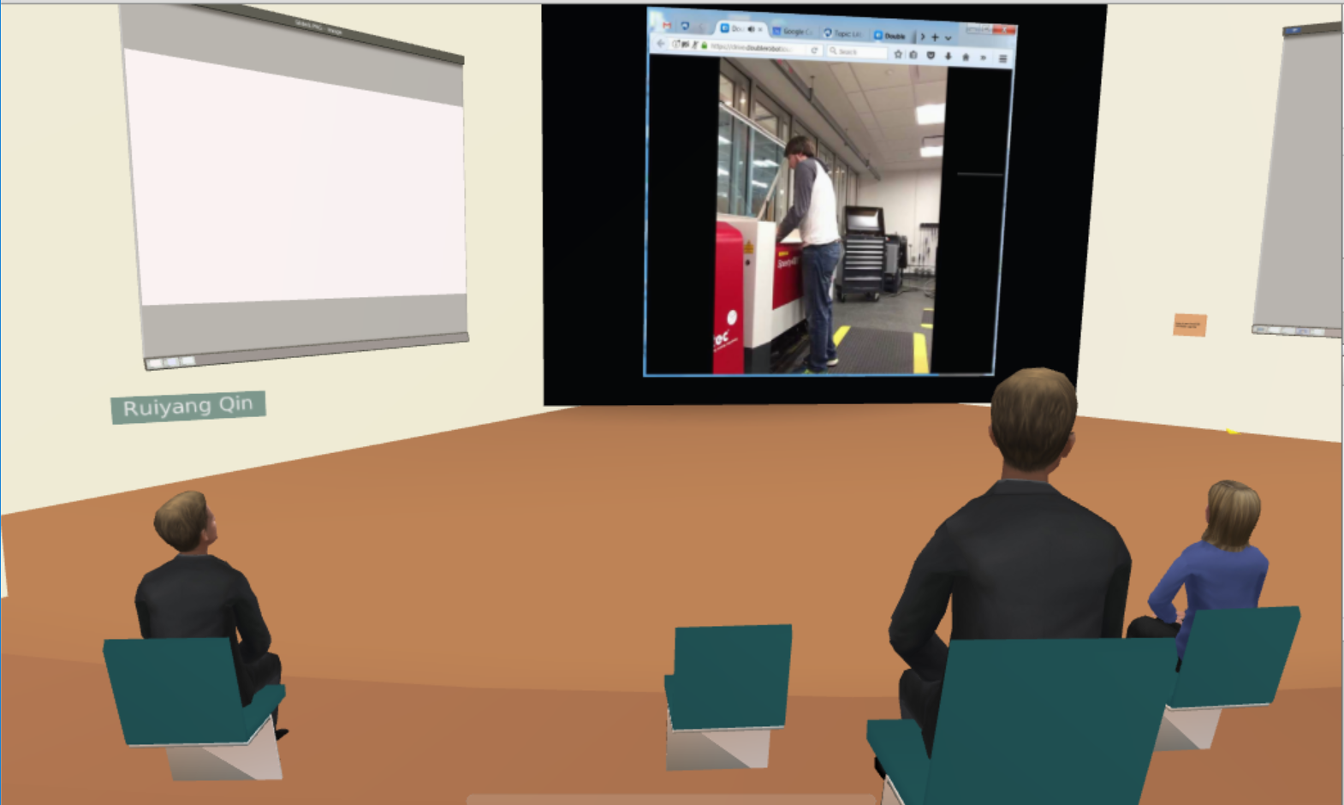

I saw the nine strategies. It just make me recall something happened on me. From the article, I think people should remember that getting a big picture is the most important thing for engineers. The picture will include not only your own part, or the whole project, but the whole industry. Knowing what is happening and what the need is will improve an engineer into a higher level. Teamwork is also an efficient way to shape the project and make some big moves. Many people should understand how this work. As a team, there will be more thoughts, more perspectives, more creative. And the most important thing is knowing how to show your idea and tell the story. I am saying that because I know for most people in the college of engineering, they are not good talkers and they just focus on their work. That’s not ok at all because if you don’t know how to tell the story, you wouldn’t be able to gain much enough investment and build the team. Only if the engineer can describe a good picture, telling others what does he want to do and how potential the project is, others will buy it. And that’s how to be a good engineer, not only just learn as much as professional skills, but have to know tons of things beyond the engineering.